Project Design Documentation

Title : Conversion of an Image into JSON file using AWS Textract

Course: Introduction to Cloud Computing – CS 5610

Instructor: Dr. Kevin (Qixiang) Pang

Team members :
Poojitha Manchi – 700758246
Sai Vikas Peddina – 700761953
Pavankalyan Nagelli – 700751765
Sannith Kumar Katla – 700757213

Project Overview:
The goal of this project is to create a system that converts an image file (such as JPG, PNG and JPEG) into structured data format that is JSON, using Amazon Web Services (AWS) Textract. By utilizing Textract's advanced optical character recognition (OCR) capabilities, the system will extract text and data from these documents. This will facilitate seamless integration into various applications and workflows. The focus will be on achieving accurate and efficient conversion while ensuring the system remains flexible and scalable.

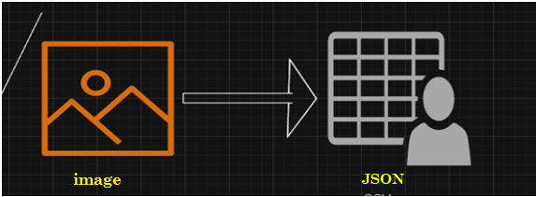

Rationale:
Many organizations handle substantial amounts of unstructured data in PDF files and images, often necessitating manual extraction and processing. By automating this process with AWS Textract, we can drastically reduce the time and resources needed for data extraction tasks. Furthermore, converting the data into structured format like JSON to improve usability and facilitates further analysis, integration, and manipulation of the extracted information. This project aims to tackle these challenges and offer a dependable solution for efficient document processing.

Project Management Methodology and Tool:
For project management, we adapted Agile approach to software development, emphasizing iterative development, continuous improvement and collaboration. We used Jira board as our project management tool.
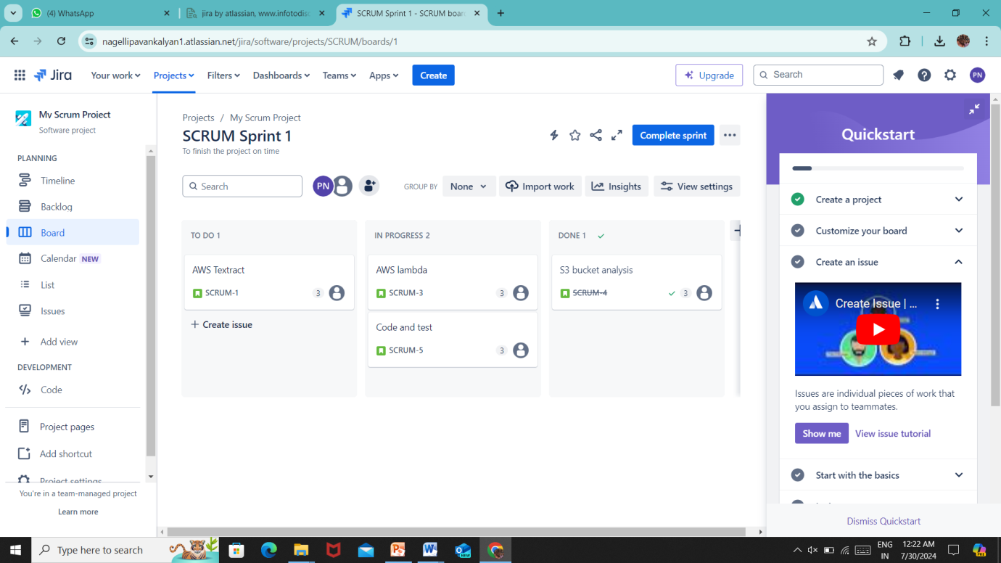

Cloud Services and Technologies Used:
In our project, we are utilizing cloud computing to create a robust and scalable solution. Here is an overview of the cloud services, platforms and technologies we are employing.
- Cloud Provider: Amazon Web Services (AWS) is our selected cloud provider due to its comprehensive service offerings, extensive global infrastructure, and proven reliability.
- Simple Storage Service (S3): We use S3 as our primary storage solution for securely saving documents, images, and other data types in the cloud.
- AWS Lambda: Lambda supports our serverless computing needs, enabling the execution of code without the need for server management or setup. This is especially useful for on-demand document processing tasks.
- Textract: AWS Textract utilizes machine learning to pull text and data from documents efficiently. This service streamlines the analysis of documents, simplifying the extraction of useful information from unstructured data.
- CloudWatch: We employ CloudWatch for the monitoring and observability of our AWS resources and applications. It assists in tracking performance metrics, identifying anomalies, and conducting real-time troubleshooting.

Architecture Overview:
Our system is built to effectively transform images into structured data format that is JSON using AWS Textract. By utilizing cloud-native services and serverless computing, our architecture guarantees scalability, reliability, and cost-efficiency.
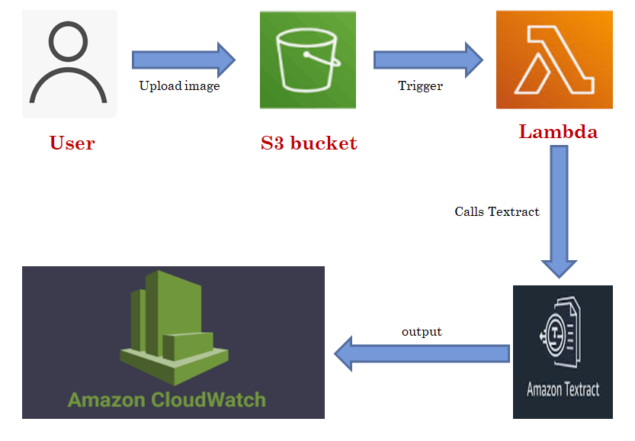

Major Components:
- Amazon S3 (Simple Storage Service):
- Functions as the storage layer for uploaded documents and intermediate processing results.
- Offers durable, scalable, and secure object storage with detailed access control through IAM policies.
- AWS Lambda Function:
- Forms the core of our serverless architecture, handling document processing tasks.
- Activated by events like file uploads to S3 or API requests from the user interface.
- Developed in Python or Node.js, these functions interface with AWS services for document analysis, data extraction, and formatting.
- AWS Textract:
- Crucial for extracting text and data from images.
- Employs advanced machine learning algorithms to identify and analyse text, tables, forms, and other structured elements within documents.
- AWS CloudWatch:
- Monitors system health, performance metrics, and operational logs for proactive troubleshooting and optimization.
- Provides insights into resource usage, execution times and error rates across the entire application stack.

Observations :
As we upload an image into the S3 bucket, it gets triggered by the Lambda function we created through which the function calls the Textract service to convert the image uploaded into JSON format which is observed in the cloudwatch logs as shown in the images below.
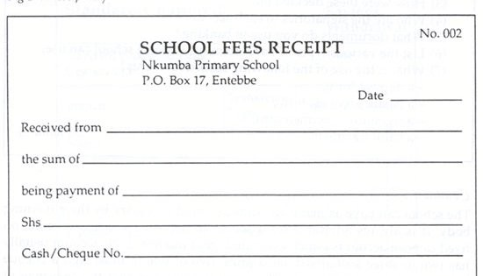

Sample image we uploaded into the S3 bucket.
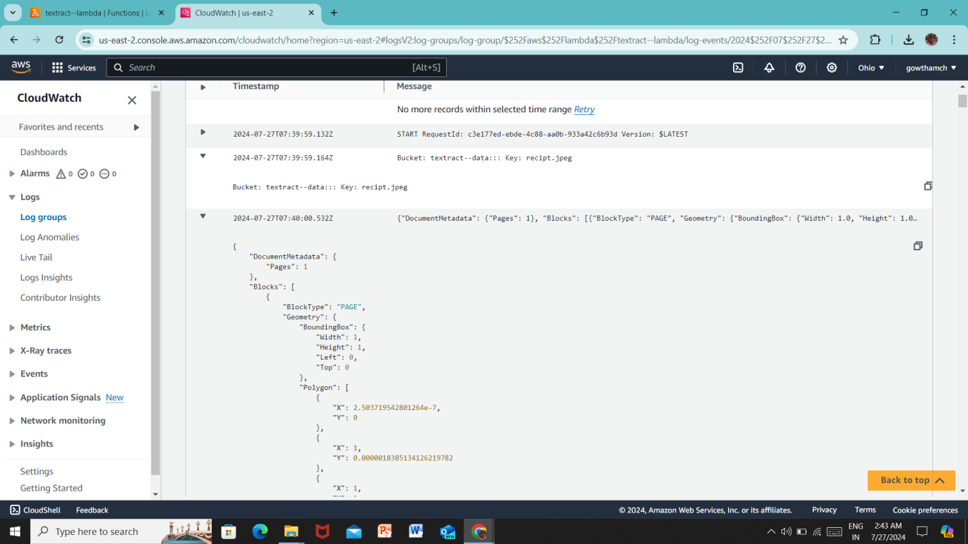
Output of the image when converted into JSON format

Future Enhancement: Integration with API Gateway for AWS Lambda:
Objective:
Integrate API Gateway with AWS Lambda to develop a user-friendly interface for the PDF and image conversion system. This enhancement seeks to ensure smooth integration with external applications while maintaining the conversion logic within Lambda functions.

Key Components:
- API Gateway Integration: Set up API Gateway endpoints to initiate AWS Lambda functions for handling PDF and image conversion requests.
- AWS Lambda Functions: Create Lambda functions with conversion logic, leveraging AWS Textract for processing PDFs and images.
- Authentication and Authorization: Integrate authentication mechanisms within API Gateway to manage access to the conversion services.
- Error Handling and Logging: Implement error handling and logging within Lambda functions using AWS CloudWatch to ensure system reliability and simplify troubleshooting.

Benefits:
- Encapsulated Logic: Maintain the conversion logic within Lambda functions, enhancing the system's modularity and ease of maintenance.
- Simplified Integration: Provide conversion services via API Gateway, offering an easy-to-use interface for external applications.
- Enhanced Security: Implement authentication within API Gateway to secure access to the conversion services.
- Scalability and Cost Efficiency: Leverage AWS Lambda's serverless architecture for automatic scaling and cost optimization, ensuring efficient use of resources.

Next Steps:
- Develop Lambda Functions: Create Lambda functions that encapsulate the logic for PDF and image conversion, utilizing AWS Textract for text extraction and data processing.
- Configure API Gateway: Establish RESTful API endpoints in API Gateway, linking them to the Lambda functions to handle conversion requests.
- Implement Authentication: Set up authentication mechanisms, such as API keys or AWS IAM, within API Gateway to manage access to the conversion services.
- Error Handling and Logging: Integrate error handling within the Lambda functions to detect and log any conversion errors using AWS CloudWatch.
- Test and Validate: Perform thorough testing of the integrated system to confirm that functionality, security, and performance meet the specified requirements.
- Deploy and Monitor: Launch the integrated system into production, and monitor its performance and usage metrics using AWS CloudWatch and other monitoring tools.
By integrating API Gateway with AWS Lambda and encapsulating the conversion logic within Lambda functions, this system will offer a secure, scalable, and cost-effective solution for image conversion, enabling seamless integration with external applications and workflows.

Conclusion:
In summary, our initiative to create a document conversion solution using AWS Textract holds substantial promise for enhancing document processing workflows and maximizing the potential of unstructured data. By leveraging cloud-native services and serverless technology, we have developed a solution that is scalable, efficient, and cost-effective, addressing the complexities of manual data extraction images.
Our architecture integrates AWS Textract, Lambda functions, S3 storage, and CloudWatch monitoring to provide reliable text and data extraction. The intuitive interface simplifies document uploads, conversion settings, and data retrieval in JSON format. With features such as asynchronous processing, customizable formatting, and real-time status updates, our solution meets diverse user needs across various industries, including automating invoice processing, extracting form information, and digitizing archival documents.
Additionally, we prioritize security and compliance, ensuring sensitive data is protected throughout the conversion process through IAM policies, encryption, and adherence to industry best practices. Our project marks a significant advancement in document conversion technology, offering organizations a powerful tool for unlocking actionable insights from unstructured data. We are enthusiastic about the potential of our solution and anticipate its broad market adoption.

References:
https://aws.amazon.com/s3/?nc2=h_ql_prod_st_s3
https://aws.amazon.com/lambda/?nc2=h_ql_prod_cp_lbd
https://aws.amazon.com/textract/?p=ft&c=arti&z=5

